IET DEPARTMENT



Sumama Rahim
F24BSCS039
Date: 12/22/2025
Data Structures

Lab 8: Queue Data Structure
Objectives:
- Queue
- Queue using Linked List Concept
- Queue using Array Concept
- Circular Queue

Practice Tasks
Task 1:
There is a garage where the access road can accommodate any number of trucks at one time. The garage is built in such a way that only the first truck entered can be moved out. Each of the trucks is identified by a positive integer (a truck_id). Write a program to handle truck moves, allowing for the following commands:
- Enter_garage(truck_ id);
- Exit_garage(truck_id);
- Show_trucks();
If an attempt is made to get out a truck which is not the closest to the garage exit, show the error message “Truck is not near garage exit door”
Input | Output
Show_trucks();  Enter_garage(2);  Enter_garage(8);  Enter_garage(1);  Enter_garage(9);  Exit_garage(2);  Show_trucks();  Exit_garage(9) | Empty garage  2  8 2  1 8 2  9 1 8 2  9 1 8  “Truck is not near garage exit door”

Solution:

// Sumama Rahim, F24BSCS039
class Garage {
int[] queue;
int front;
int rear;
int size;
int cap;

Garage(int cap) {
this.cap = cap;
this.queue = new int[cap];
this.front = 0;
this.rear = -1;
this.size = 0;
}

void Enter_Garage(int truckId) {
if (size < cap) {
rear = (rear + 1) % cap; // i used % to solve overflow isssue
queue[rear] = truckId;
size++;
System.out.println("Truck " + truckId);
} else {
System.out.println("Garage is full!");
}
}

void Exit_Garage(int truckId) {
if (size > 0 && queue[front] == truckId) {
System.out.println("Truck " + truckId + " exited the garage.");
front = (front + 1) % cap; // i used % to solve overflow isssue
size--;
} else {
System.out.println("Truck is not near garage exit door.");
}
}

void showTrucks() {
if (size == 0) {
System.out.println("Garage is empty.");
} else {
System.out.print("Trucks in the garage: ");
int i = front;
for (int j = 0; j < size; j++) {
System.out.print(queue[i] + " ");
i = (i + 1) % cap; // i used % to solve overflow isssue
}
System.out.println();
}

}

}

class Main {

public static void main(String[] args) {
Garage list = new Garage(6);
list.Enter_Garage(10);
list.Enter_Garage(20);
list.Enter_Garage(30);
list.showTrucks();
list.Exit_Garage(10); // this should remove
list.showTrucks(); // now 20 and 30 are in garage
// i want to exit the truck ID 30 from the garage
list.Exit_Garage(30); // this should not allowed for exit
list.showTrucks();

}
}

Output:

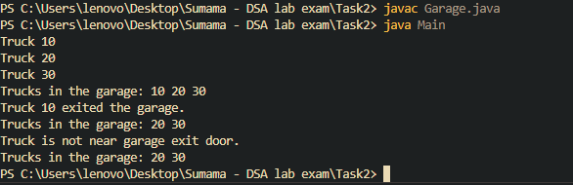

Task 2: The Josephus Problem (circular link list)
There are n people standing in a circle waiting to be executed. After the first man is executed, k - 1 people are skipped and the k-th man is executed. Then again, k-1 people are skipped and the k-th man is executed. The elimination proceeds around the circle (which is becoming smaller and smaller as the executed people are removed), until only the last man remains, who is given freedom. The task is to choose the place in the initial circle so that you survive, given n and k.
N=5, K=2 (first node =1)
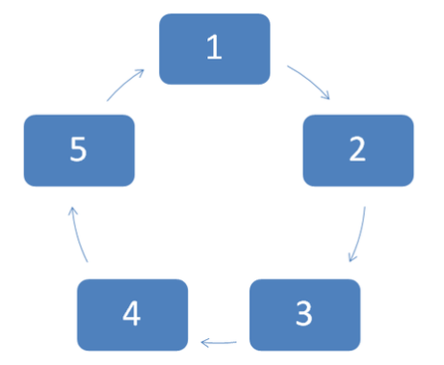

Solution:

// Sumama Rahim
// F24BSCS039

class JosephusProblem {

//Represents the node of list.
public class Node {

int data;
Node next;

public Node(int data) {
this.data = data;
this.next = null;
}
}
//Declaring head and tail pointer as null.
public Node head = null;
public Node tail = null;

//This function will add the new node at the end of the list.
public void add(int data) {
//Create new node
Node newNode = new Node(data);
//Checks if the list is empty.
if (head == null) {
//If list is empty, both head and tail would point to new node.
head = newNode;
tail = newNode;
newNode.next = head;
} else {
//tail will point to new node.
tail.next = newNode;
//New node will become new tail.
tail = newNode;
//Since, it is circular linked list tail will point to head.
tail.next = head;
//or newNode.next = head;
}
}

// Function to solve the Josephus
int solveJosephus(Node head, int k) {
Node S = head;

while (S.next != S) {
// Move k-1 steps
for (int i = 2; i < k; i++) {
S = S.next;
}

// Removing the k-th node
Node nodeToRemove = S.next;
System.out.println("Removed: " + nodeToRemove.data);

S.next = nodeToRemove.next;
S = S.next;
}
return S.data;
}

public static void main(String[] args) {
JosephusProblem list = new JosephusProblem();

// adding data to the list - we need n = 5
list.add(1);
list.add(2);
list.add(3);
list.add(4);
list.add(5);

int k = 2; // k-th should executed and k-1 should ignored

int survived = list.solveJosephus(list.head, k);
System.out.println("Last Person: " + survived);
}
}

Output:

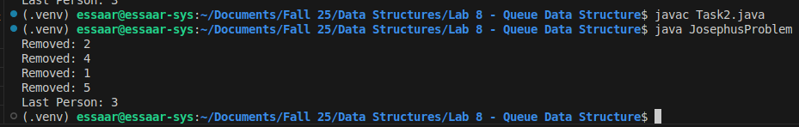
Out comes
The outcomes of this lab were:
- Queue
- Queue using Linked List Concept
- Queue using Array Concept
- Circular Queue

